
Lab 1- bit.ly/3SsNbj4

Name | Nazar Luhovyi
Date | 22/01/2026
Student No | S00286478
Student Email | S00286478@atu.ie

GitHub
- Make a copy of this document on Google Docs
- Go to http://github.com
- Sign up for a GitHub Account (make sure to use your ATU Sligo student email address when you signup as this will entitle you to a free Student that includes 5 free private repositories.)
- Enter your GitHub username here and also enter it into this form:
NazarLuhovyi

- Once your account has been setup, try creating a new Repository called firstrepo using the Add Repository button below your profile picture.
- Use the Add File button to add a new file to your repository, give your new file a name, type some text and save the file.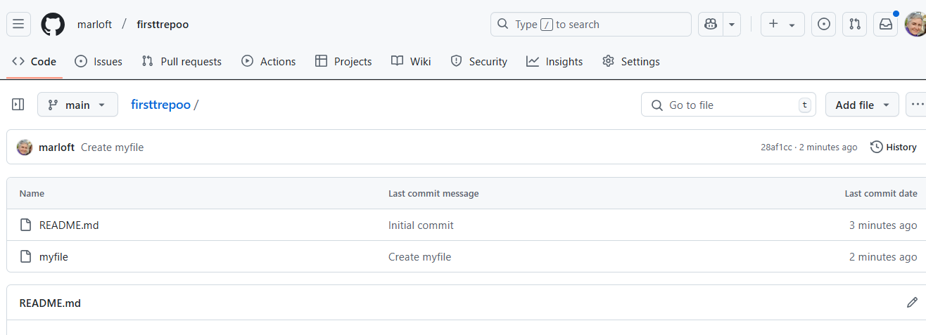

Arduino IDE & Coding Basics

- Find the Blink tutorial on the Arduino Website
https://www.arduino.cc/en/Tutorial/BuiltInExamples/Blink
- Open the Blink Sketch in the Wokwi emulator here: https://bit.ly/3S8HxS6:
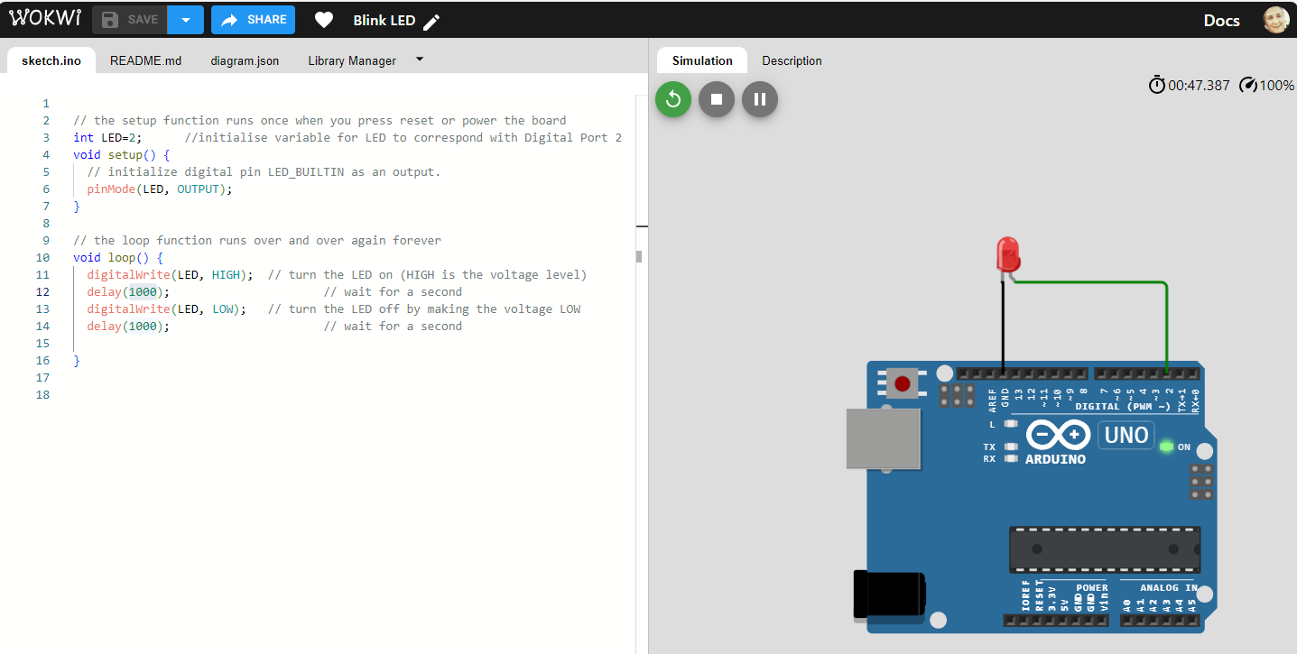
- Change the blink delay values to 500 - what will be the effect of this change?
The light start blinking faster than it was

- Add a ‘modified by’ line to the sketch comment at the top, with your name and date and paste a screen shot replacing this one:
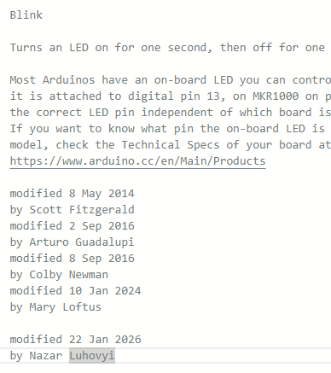
- Upload your version of Blink to your GitHub account and provide the link here:
NazarLuhovyi/firstrepo: Internet of things

- Paste a screenshot here of your code uploaded to GitHub
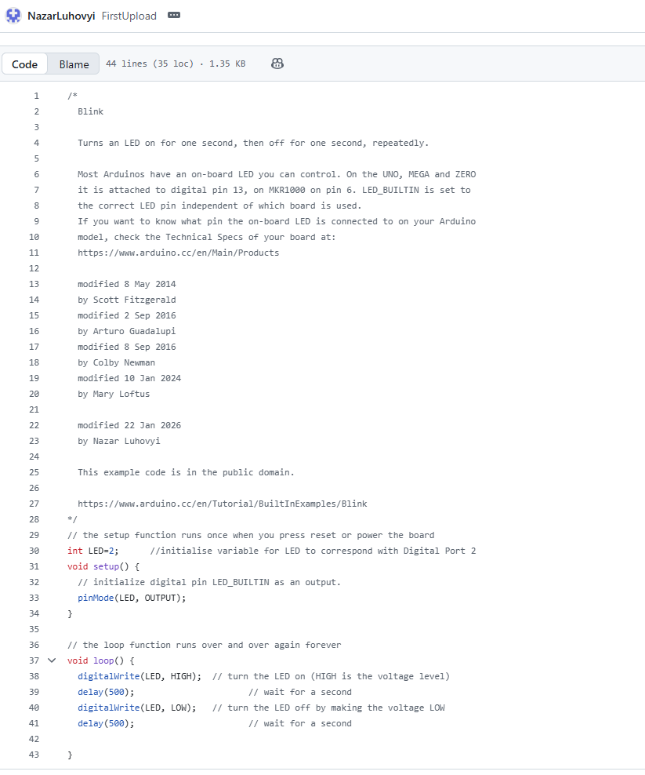

- Upload your Lab to Moodle!

